Video for website
- Animation of the app
- RMIT activator https://www.facebook.com/rmitactivator/videos/319117869029064/UzpfSTU3MDMyMjMzNjoxMDE1NjI1NTk1Mjg3NzMzNw/

Website theme examples:

- Dark, clean, minimalist, modern, aerated, no clutter, space, with a hint of red
- Animation and video for a dynamique and engaging website, avoid static boring
- Visuals to support explanation without the need of content (self explanatory)
- http://www.nerisson.fr/#home
- Apple announcements and new release style https://www.apple.com/au/iphone-xs/
- http://charactersf.com/
- A welcome page with just our brand presence like this https://www.petites-sorcieres.com/fr/ (have just the logo with the whale shark slowly swimming, or animation of the app)
- The loading symbol could be the trio of sharks swimming upward
- Strong branding throughout https://bpmcorp.com.au/
- A strong and vibrant website with elements of black and red throughout and has conveyed a sense of luxury/ high quality. https://www.masterclass.com/?utm_source=Paid&utm_medium=AdWords&utm_campaign=MC&utm_content=Brand-{keyword}-G1_EM&utm_term=Aq-Prospecting&gclid=CjwKCAjw__fnBRANEiwAuFxETx5F1eDcHaJrlNenV24OdlPa2UYX_cqfqbqEgoZktpc1fONYMOh3YRoCfMUQAvD_BwE
- A retail service that gives brands a white-label app - so they don’t surf the web - they use the app instead. The website is simple, nice animations and gives an overview of the entire service package without confusion.https://tapcart.co/

Take a look at this coming soon landing page we can incorporate:
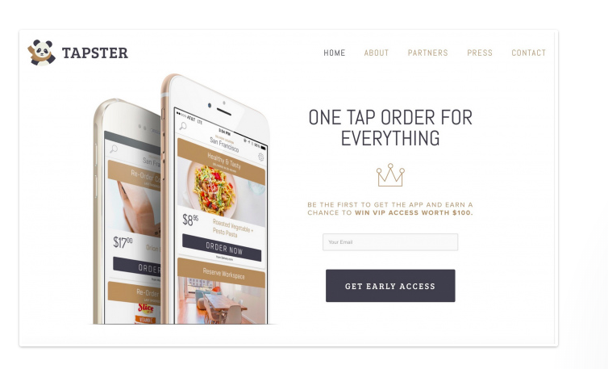

- I don’t like the stale images of the app without context or animation - but what I really like is a separate landing page for our end users (especially when we launch our go-to-marketing B2C campaign) and it has a sales funnel of “get early access”.

